
CISB3313
FUNDAMENTALS OF DATABASE
Database Project
GROUP 10
Group Members:
Name | Student ID
HARIZ IRFAN BIN MOHD SHAMIR | BSW01085154
WAN MOHAMAD AZRIQ BIN WAN MOHAMAD AZREN | CS01085133
MUHAMAD ZAKHWAN BIN SHAMSUL ANU AR | CS01085237

T
Table of contents
no | Section | Pages
1 | Diagram  - Use Case Diagram  - Class Diagram
2 | documentation formatting
3 | coding file formatting
4 | naming conventions – dictionary
5 | function and methods modularity
6 | continuous integration rules

  - USE CASE DIAGRAM

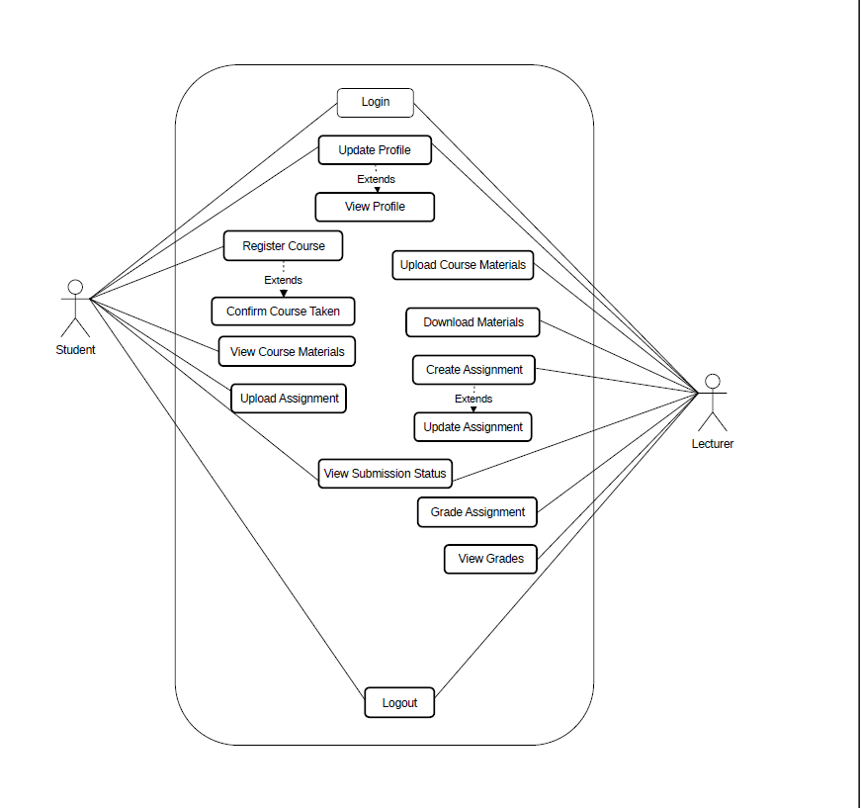

1.2 CLASS DESIGN

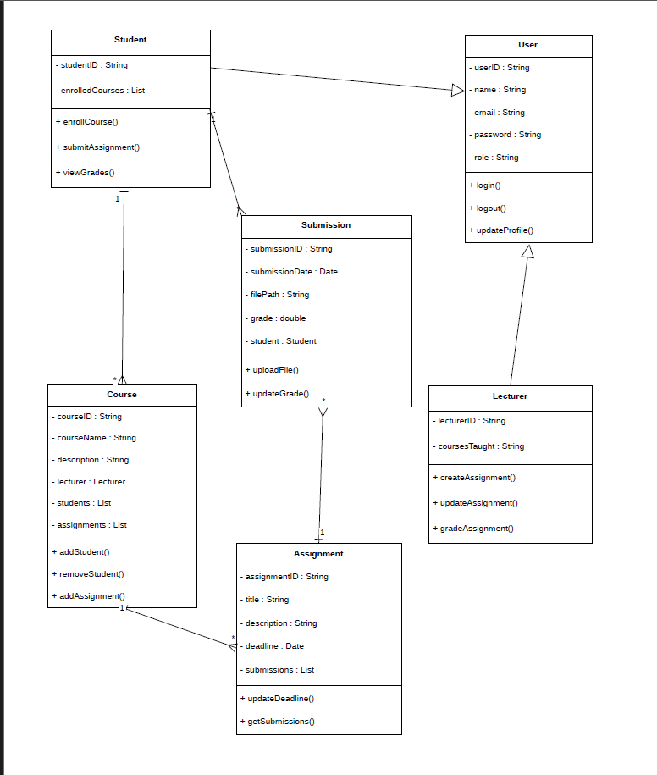

Part 2: Documentation Formatting
Font Style: Times New Roman.
Font Size:
-Size 12 for body text, headers, and footers.
-Size 15 for Subheadings
-Size 20 with a red color,bold and italic for section headings.
Allignment:
-Left side of the page
Page Numbering :
-the bottom middle of the page (not include the cover page and table of contents)
Line spacing: 1.15

Heading format:
1.0 Main Heading
1.1 Subheading

Table format :
Cover page
Table of contents
Introduction
Conclusion

3.0 coding file formatting

3.1 Code Style Rule:
Language: Java
Indentation: 4 spaces
No tab mixing
Naming convention: Ensure any files or variables are agreed-upon to improve readability.
Max line length: 100 characters
Curly brackets on same line:
public void login() {

Comment:Added as a reminder,note and explaination for a line or the class of the code
comment format:
/* This method validates login*/

Each source files must follow;
Package Declaration
Import Statements
Class Declaration
Attributes
Constructors
Methods

Code Organization Rules
-One public class per file.
-File name must match class name.
-Avoid unused variables/imports.

Define Naming Conventions

5.Define Function and Methods Modularity

SLMS will be divided into independent modules where each function has a single responsibility. This approach makes the system easier to manage and ensures maintainability, scalability, and easier debugging of the SLMS system.

Module | Responsibility
Authentication Module | Login and logout
User Management Module | Manage users
Course Module | Course creation & enrollment
Assignment Module | Assignment handling
Grading Module | Marks and feedback

1. Single Responsibility Principle
Each method will perform one specific task
• Input Methods: inputStudentData() will handle user entries only.
• Logic Methods: CalculateGrade() will focus purely on calculating the grade of the students

2.High Cohesion
Function inside the module must be related .

Module | Function

5.3 Method design rules
Rule | Description
Method Length | Less or equal 40 lines
Parameters | 5 at most
Return Value | Value needed
Reusability | Avoid logic duplicate

Continuous Integration Rules

6.1 Purpose
Continuous Integration ensures collaborative development and prevents integration conflicts

6.2 Version Control Platform
SLMS development uses GitHub repository.

6.3 Development Workflow
- Pull latest develop branch.
- Create feature branch.
- Implement feature.
- Commit changes.
- Push to GitHub.
- Create Pull Request.
- Review before merge.

Each feature must use separate branch:
- feature-login
- feature-course-module
- Pull Request required before merge

Code must pass:
- No compilation errors
- No warnings

Commit message format:
[Module] Short description
Example: [Login] Added password validation

